Course/ Subject/Level: | BSc (Hons) Computing & BEng (Hons) Software Engineering  SWE6204- Machine Learning Level: 6
Learning Outcome | After completing this session, you will be able to work towards:  LO2: Identify fundamental issues of applying Machine Learning in designing and implementing real-world applications.  LO3: Demonstrate the application of machine learning algorithms to solve real-world problems.
Topic: | Tutorial: Installation of Tool-Anaconda
Week | 2 | Time Duration: | 10:00 to 5:00

Learning Method: Practical and Peer Review
References:
Anaconda.,2022,Anaconda Documentation. [Online]
Available at: https://docs.anaconda.com/anaconda/navigator/
Anaconda,2022.Individual Edition. [Online]
Available at: https://www.anaconda.com/products/individual
To Practise Examples from: https://www.w3schools.com/python/python_syntax.asp
In the given tutorial, you will walk through various tasks of installation of Anaconda Navigator and launch jupyter notebook for working with Python and data visualisation. Ensure to follow the various stages accordingly as given below.
https://www.anaconda.com/products/individual
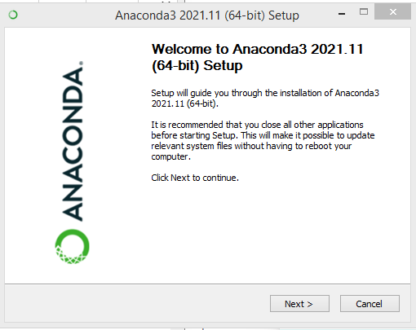

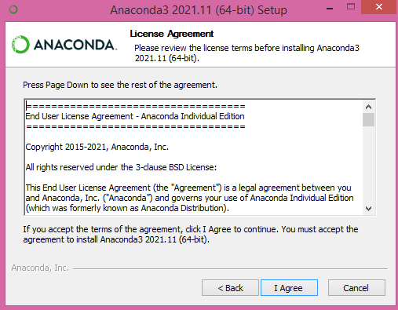

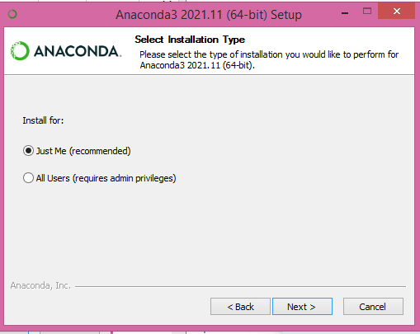

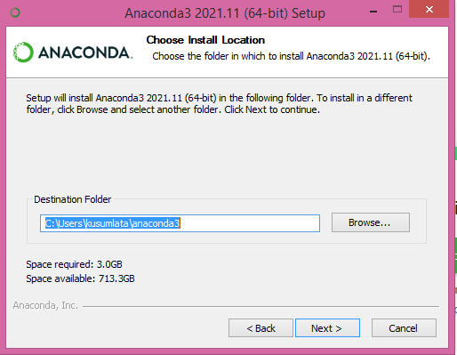

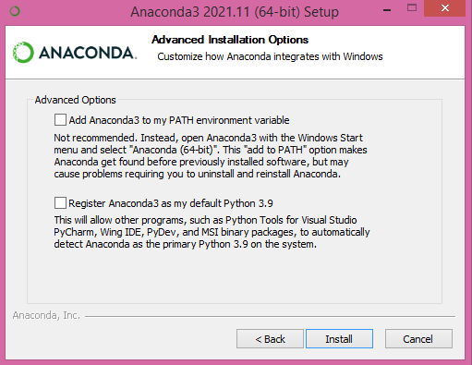

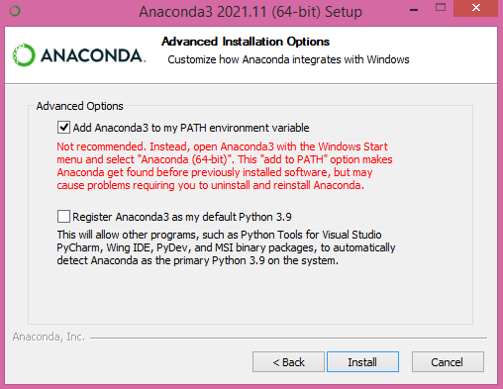

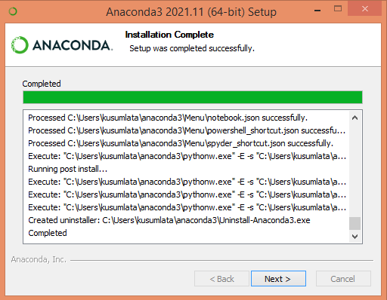

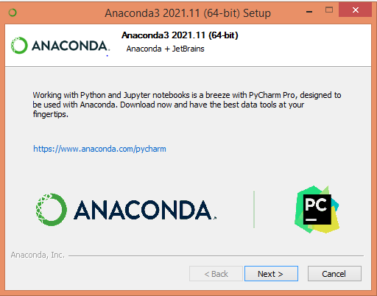

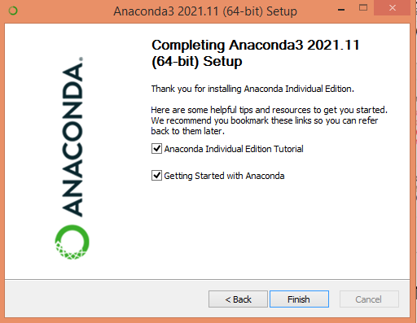

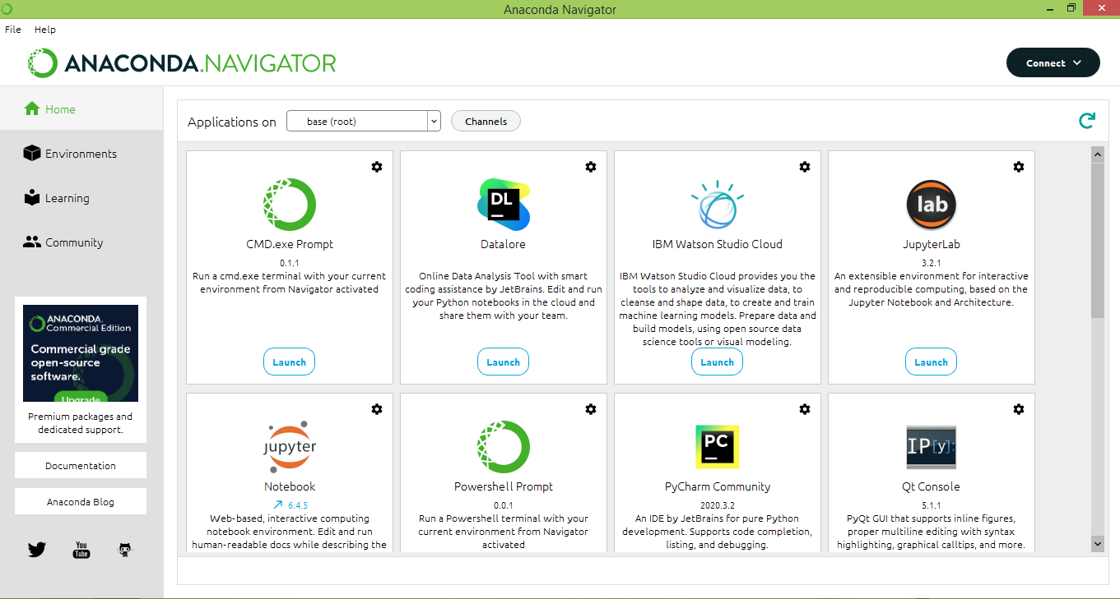

After finishing the installation, launch jupyter notebook for working with Python

Discussion or any points to share:

